## FPT ACADEMY INTERNATIONAL FPT – APTECH COMPUTER EDUCATION



### Centre Name: ACE-HCMC-2-FPT.

**Address: 590 Cach Mang Thang 8, District 3, Ho Chi Minh City, Viet Nam.**

Chic Lighting & Design

|  |  |  |
| --- | --- | --- |
| **Supervisor:** | Ms. Le Mong Thuy | |
| **Semester:** | 1 | |
| **Batch No:** | T1.2406.M1 | |
| **Group No:** | 4 | |
| **Order:** | **Name** | **Student ID** |
| 1. | Nguyen Do Hoang Hiep | Student1571997 |
| 2. | Nguyen Khai Nguyen | Student1575541 |
| 3. | Nguyen Thanh Nam | Student1573726 |

Date: Sep - 2024

### This is to certify that

**Mr.** Nguyen Do Hoang Hiep

**Mr.** Nguyen Khai Nguyen

**Mr.** Nguyen Thanh Nam

### have successfully designed & developed:

eProject: Chic Lighting & Design

### Submitted by:

Ms. Le Mong Thuy

**Date of issue:** Oct 14th 2024

### Authorized Signature:

**Table of Contents**

ACKNOWLEGMENT 3

SYNOPSIS 3

ANALYSIS 3

1. Purpose of the Website 3
2. Design and Interface 3
3. Technical Requirements 4

CUSTOMER'S REQUIREMENTS SPECIFICATIONS 4

1. Business/Project Objective 4
2. Hardware/ Software Requirements 5
   1. Hardware 5
   2. Software 5

SCOPE OF THE WORK (IN BRIEF) 6

1. Home 6
2. About Mountaineering 6
3. Records: Mountaineering records 6
4. Organizations 6
5. Gallery 6
6. Developments 6
7. Guidelines 6
8. Contact : Contact information for users to reach out or send feedback 6

ARCHITECTURE AND DESIGN OF THE SYSTEM 7

. 7



DIAGRAM OF THE WEBSITE 8

TASK SHEET REVIEW 1 9

SITE MAP 10

MOCK OF THE WEBSITE 11

1. Home 11
2. Mountaineering 12
3. Record 13
4. Organizations 14
5. Library 15
6. Develop 16
7. Guide 17
8. Contact 18

TASK SHEET REVIEW 2 19

WEBSITE DESCRIPTION 20

1. Home 20
2. Moutaineering 21
3. Record 24
4. Organization 25
5. Library 26
6. Develop 27
7. Guide 28
8. Contact 28

TASK SHEET REVIEW 3 30

## ACKNOWLEGMENT

On behalf of all team members, we would like to express our heartfelt gratitude to everyone who support us throughout the completion of this Chic Lighting & Design eProject. Special thanks to our supervisor, Ms. Le Mong Thuy, who meticulous, enthusiastic, and dedicated guidance was instrumental in our success. Her continuous support and mentorship provided us with the direction and motivation needed to complete this project.

We also extend our sincere thanks to all team members for their hard work and dedication throughout the month-long effort. Your commitment and earnest contributions were crucial to our success.

Finally, we are grateful to our classmates for creating an encouraging environment that allowed us to focus on our project and achieve our goals. Your support and motivation were greatly appreciated.

## SYNOPSIS

Chic Lighting & Design is developing a comprehensive online platform to showcase a curated selection of lighting fixtures and accessories. The platform will feature detailed product descriptions with high-quality images, advanced search capabilities, and a user-friendly interface. The goal is to create a visually appealing and informative resource for both residential and commercial customers to explore and research lighting options.

## ANALYSIS

### Purpose of the Website.

Our website offers a vast collection of decorative and functional lighting fixtures, carefully curated to suit every style and taste. From elegant chandeliers to modern pendant lights, we have everything you need to illuminate your space with style and sophistication. Explore our extensive range of products, learn about the latest lighting trends, and find expert advice to help you create a truly stunning ambiance in your home.

### Design and Interface.

* + The website features a user-friendly environment and navigation. Key menus are positioned at the top for easy access to information.
  + The interface and color scheme are harmoniously combined to create a visually appealing and engaging experience for users.

### Technical Requirements

* + The website must perform well across all major browsers including Chrome, IE, Firefox, etc., ensuring accessibility from various devices and platforms.
  + It utilizes a Single-Page-Application (SPA) approach to deliver a seamless and fast web browsing experience.
  + Features are designed to meet technical requirements, facilitating quick and accurate loading and display of information.

The mountaineering website aims to be a valuable and attractive source of information for enthusiasts, providing everything from basic knowledge to practical insights from experts in the field.

## CUSTOMER'S REQUIREMENTS SPECIFICATIONS

### Client: APT India Co.

### Business/Project Objective

The portal will be designed as a Single-Page-Application and responsive Website with a set of pages and menus that represent choice of activities to be performed. The pages, menus, and other visual elements must be designed in a visually appealing manner with attractive fonts, colors, and animations.

All of these should also be laid out in a responsive manner

The Web site is to be created based on the following requirements.

1. The Top of the Page should be presented with a suitable logo and images of Lights & Chandeliers.
2. The site must contain the various sections such as CEILING LIGHTS, WALL LIGHTS, LAMPS, OUTDOOR LIGHTS, FANS and HOME ACCENTS etc.
3. Section on LED Lights should be provided with various products listed such as Spot Lights, Decoration Lights, Smart Lights etc.
4. Specification and Pricing of Lights should be added along with the images.
5. A menu on the Top with all sections listed should be provided.
6. Website should provide section filter for various brands offered in the store.
7. Gallery section should be added for viewing different images.
8. Feedback must be allowed to enter by the viewer
9. Site map, Gallery, About us, FAQ link, Contact us must be added.
10. The complete description must be allowed to get download as pdf or doc file.
11. Section for various offers in the store should be provided with listing of offers with details.

Over and above this, the portal should implement the following functionalities:

* Display a continuous scrolling ticker at the bottom of the page with current date, time, and location (hint: Use geolocation features of HTML5).
* Display a visitor count at the top right corner of the page beside a logo image.
* The menu options should change color on hover and also after clicking.
* Fade in and fade out options can be used for the menus.

### Hardware/ Software Requirements

### Hardware

* + - Intel Core i3/i5 Processor or higher
    - 8 GB RAM or above
    - Color SVGA
    - 500 GB Hard Disk space
    - Mouse
    - Keyboard

### Software

Technologies to be used:

* + - Frontend: HTML5, CSS, Bootstrap, JavaScript, jQuery, React/AngularJS, Figma, XML
    - Data Store: JSON files or TXT files Other Requirements:
    - Operating Portal: Windows
    - Browsers: Edge, Chrome, Mozilla Firefox, Safari

# SCOPE OF THE WORK (IN BRIEF)

### Home:

* + Displays an image of Lights & Chandeliers with the website's logo.

### About Products

* + **CEILING LIGHTS**
  + **WALL LIGHTS**
  + **LAMPS**
  + **OUTDOOR LIGHTS**
  + **FANS**
  + **HOME ACCENTS**
  + **LED Lights:** be provided with various products listed such as Spot Lights, Decoration Lights, Smart Lights etc.

1. **Products information:** add Specification and Pricing along with the images

### Menu icon: a menu on the Top with all sections listed

### Filter : for various brands offered in the store

### Gallery

### Viewing a list of different images

1. **Feedback:** place for users can write feedback
2. **Sites:**

* **Products:** show a list of products
* **Site map:** show a image of site location map with information
* **Gallery:** viewing list of different images
* **About us:** introduce about the store, team and vision
* **FAQ link:** Show some frequently asked questions and answers
* **Contact us:** Contact information for users to reach out or send feedback

## ARCHITECTURE AND DESIGN OF THE SYSTEM

Webpage request

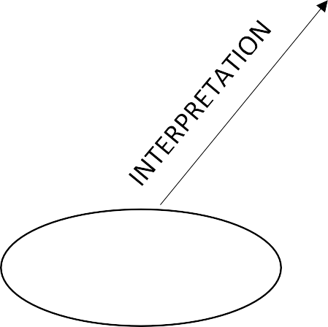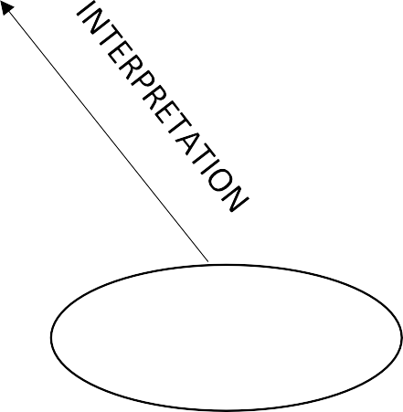

**CLIENT**

**WEB BROWSER**

Requested Page

**RENDERING**

**ENGINE**

**CSS CODE**

**HTML CODE**

**SERVER**

**WEB SERVER**



**DIAGRAM OF THE WEBSITE**

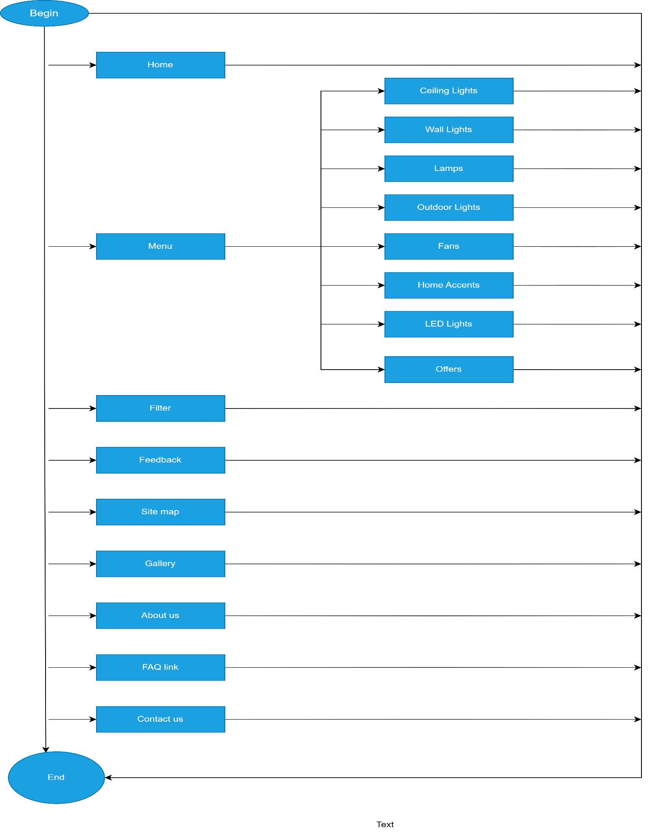



**TASK SHEET REVIEW 1**

|  |  |  |  |  |  |  |  |
| --- | --- | --- | --- | --- | --- | --- | --- |
| **Project Ref. No.: eP/Advertisement Portal Management System/01** | | **Project Title:** | **Activity Plan Prepared By:** | **Date of Preparation of Activity Plan:** | | | |
| **Sr.No** | **Task** | **Actual Start Date** | **Actual Days** | **Team Mate Names** | **Status** |
| 1 | Synopsis | Alpine Ascents | Sinh | 21/06/24 | 1 | Hiep | Completed |
| 2 | Analysis | 21/06/24 | 1 | Hiep | Completed |
| 3 | The scope of the work (in brief) | 21/06/24 | 1 | Nguyen | Completed |
| 4 | Architecture and design of the system | 23/6/24 | 1 | Nguyen | Completed |
| 5 | Diagram of the website | 23/6/24 | 1 | Nam | Completed |
| 6 | Task Sheet Review | 23/6/24 | 1 | Nam | Completed |

|  |  |
| --- | --- |
| **Date:** | |
| Signature of Instructor:  **Le Mong Thuy** | Signature of Team Leader:  **Nguyen Do Hoang Hiep** |



**SITE MAP**

## MOCK OF THE WEBSITE

### Home

### Products

### About us

**COMPARE PAGE**

### Gallery

1. **Contact us**

1. **FAQ**



**TASK SHEET REVIEW 2**

|  |  |  |  |  |  |  |  |
| --- | --- | --- | --- | --- | --- | --- | --- |
| **Project Ref. No.: eP/Advertisement Portal Management System/01** | | **Project Title:** | **Activity Plan Prepared By:** | **Date of Preparation of Activity Plan:** | | | |
| **Sr.No.** | **Task** | **Actual Start Date** | **Actual Days** | **Team Mate Names** | **Status** |
| 1 | Site map | Chic Lighting | Hiep | 14/9/24 | 2 | Hiep | Completed |
| 2 | Mock of website | 14/9/24 | 2 | Nguyen | Completed |
| 3 | Task sheet Review | 14/9/24 | 2 | Nam | Completed |

|  |  |
| --- | --- |
| **Date: 27/06/2024** | |
| Signature of Instructor:  **Ms. Le Mong Thuy** | Signature of Team Leader:  **Nguyen Do Hoang Hiep** |

**WEBSITE DESCRIPTION**

### Home

* 1. Description:
* This is a website programmed about Chic Lighting, and here are some detailed guidelines for using the website.
  1. Screenshot:

**Header:**

1. Description:

* This section will always be on top of all pages of the website.
* From here users can easily jump into any categories at any time or return to the homepage by clicking on the name of the elements in the menu which they are interested in.
* Clicking on the logo or home icon will take you to the homepage.
* Clicking on the links will direct you to the articles you want to read.

1. Screenshot:



**Products demontration:**

1. Description

* This section summarizes information about the products.
* Here users can see information about products and more about a specific product type by clicking the show more button below.

1. Screenshot

**Offers:**

1. Description

* This section displays the offers.

1. Screenshot

## - Footer:

1. Description:

* More information about Chic Light & Design with time at user location

1. Screenshot

### Feedback:

1. Description:

* Allow you to leave feedback

1. Screenshot:

### Download Description:

1. Description:

* When clicked, it will download the complete description of website as docx

1. Screenshot:

### Products

* 1. Description:
* This section displays all of the store's product categories, along with a menu that allows you to navigate to each product category.

b) Screenshot:

### Menu:

1. Description:

* Displays a list of product categories and takes you to each category's page by clicking on it.

b)Screenshot:

### Filter:

* 1. Description:
* Allows you to filter product lists based on brand
  1. Sreenshot:

### Products list:

### Description:

### Display list of products with detail

### Screenshot

### About us

* 1. Description:
* About the store and partners

b)Screenshot:

### Site map

* 1. Description:
* Display sitemap, help users easily navigate to pages
  1. Screenshot:

1. **Gallery**
   1. Description:

* Display more pictures about products and store.
  1. Screenshot:

### Contact

* **Contact list:**
  1. Description:
* Display a list of store contacts
  1. Screenshot:

### Map:

### Description:

### Display location map and information to visit.

### Screenshot:

### FAQ

* 1. Description:
* Display common questions and answers
  1. Screenshot:

|  |  |  |  |  |  |  |  |
| --- | --- | --- | --- | --- | --- | --- | --- |
| **Project Ref. No.: eP/Advertisement Portal Management System/01** | | **Project Title:** | **Activity Plan Prepared By:** | **Date of Preparation of Activity Plan:** | | | |
| **Sr.No.** | **Task** | **Actual Start Date** | **Actual Days** | **Team Mate Names** | **Status** |
| 1 | Home | Chic Lighting | Hiep | 23/9/24 | 3 | Hiep | Completed |
| 2 | Products |
| 3 | About Us |
| 4 | Site Map | 26/9/24 | 3 | Hiep | Completed |
| 5 | Gallery |
| 6 | Contact |
| 7 | FAQ | 29/9/24 | 2 | Hiep | Completed |



**TASK SHEET REVIEW 3**

|  |  |
| --- | --- |
| **Date:** | |
| Signature of Instructor:  **Ms. Le Mong Thuy** | Signature of Team Leader:  **Nguyen Do Hoang Hiep** |